Our Blood Sweat and Tears (Achievements)
🏆 1. Global Music Achievements
- Became one of the most influential music groups in the world.
- First South Korean group to reach No. 1 on the Billboard Hot 100.
- First K-pop group nominated for a Grammy Award.
- First Korean act to headline and sell out Wembley Stadium.
- First Korean group to top the Billboard 200 chart.
🌍 2. Billboard Records
- Multiple No. 1 albums on the Billboard 200.
- Multiple No. 1 singles on the Billboard Hot 100.
- "Dynamite" became their first song to debut at No. 1 on the Billboard Hot 100.
- "Butter" achieved multiple weeks at No. 1 on the Billboard Hot 100.
- "Life Goes On" became the first primarily Korean-language song to debut at No. 1 on the Billboard Hot 100.
🎵 3. Historic Music Moments
- "Dynamite" earned BTS their first Grammy nomination.
- "Butter" received a Grammy nomination for Best Pop Duo/Group Performance.
- "My Universe", their collaboration with Coldplay, reached No. 1 on the Billboard Hot 100.
- "Boy With Luv" featuring Halsey became one of their most successful collaborations.
- "Spring Day" became one of their most beloved and enduring songs.
🏅 4. Awards & Recognition
- Multiple Billboard Music Awards.
- Multiple American Music Awards.
- Multiple MTV Video Music Awards.
- Multiple Mnet Asian Music Awards (MAMA).
- Multiple Golden Disc Awards.
- Multiple Melon Music Awards.
🌐 5. Global Influence
- Addressed the United Nations General Assembly on youth and self-love.
- Appointed Special Presidential Envoys for Future Generations and Culture in 2021.
- Delivered a speech at the United Nations in support of the Sustainable Development Goals.
- Performed at major international events, including the 2021 United Nations SDG Moment.
- Inspired millions of people worldwide through music and messages of self-love.
💜 6. A Special Bond with ARMY
- Created a global fandom known as ARMY.
- Built a connection with fans beyond language and cultural barriers.
- Inspired people through messages of self-acceptance, hope, and courage.
- Used music to bring people from different countries and cultures together.

"We didn't just make history. We made memories, broke boundaries, and found a family across the world."
Seven members. One journey. Countless hearts. Forever BTS. 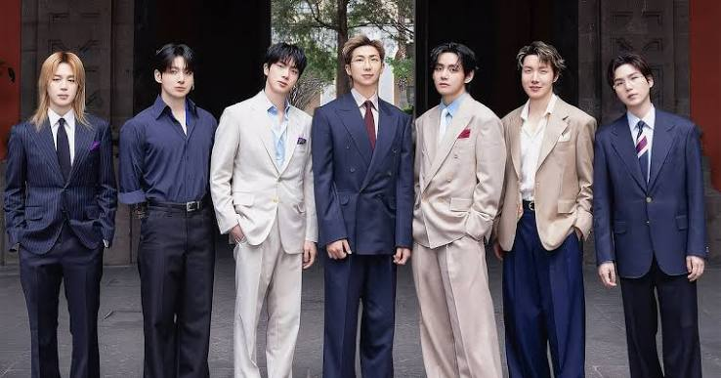]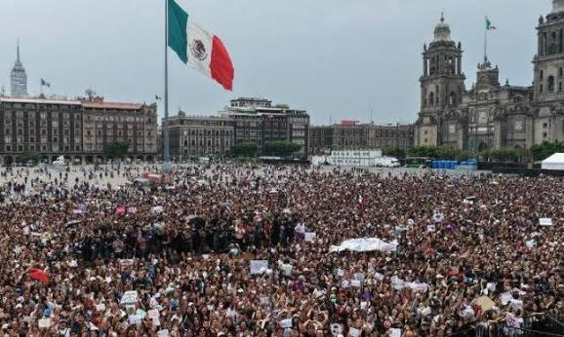
6th May 2026 National Palace of Mexico, Here is a ready-to-use, engaging Instagram caption combining all those highlights:
A historic balcony moment in Mexico City💜
When 50,000 passionate ARMY turned the National Palace into a sea of purple, BTS surprised everyone with an unforgettable appearance following a special presidential invitation.
From RM’s heartfelt words of gratitude to V melting everyone's hearts by speaking in Spanish, this wasn't just a speech—it was a pure celebration of love, culture, and an unbreakable global bond. ✨
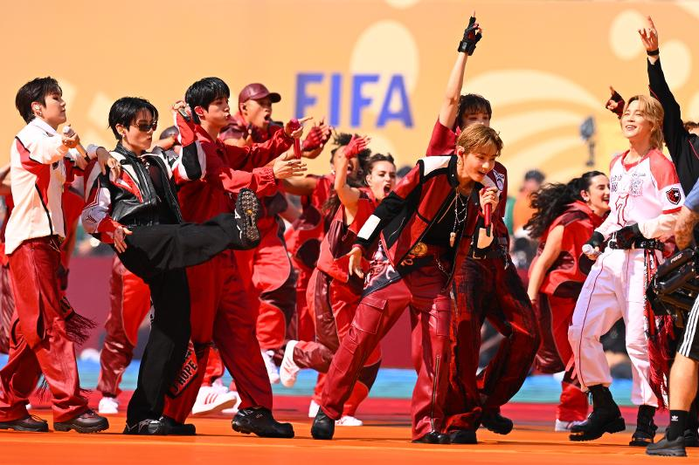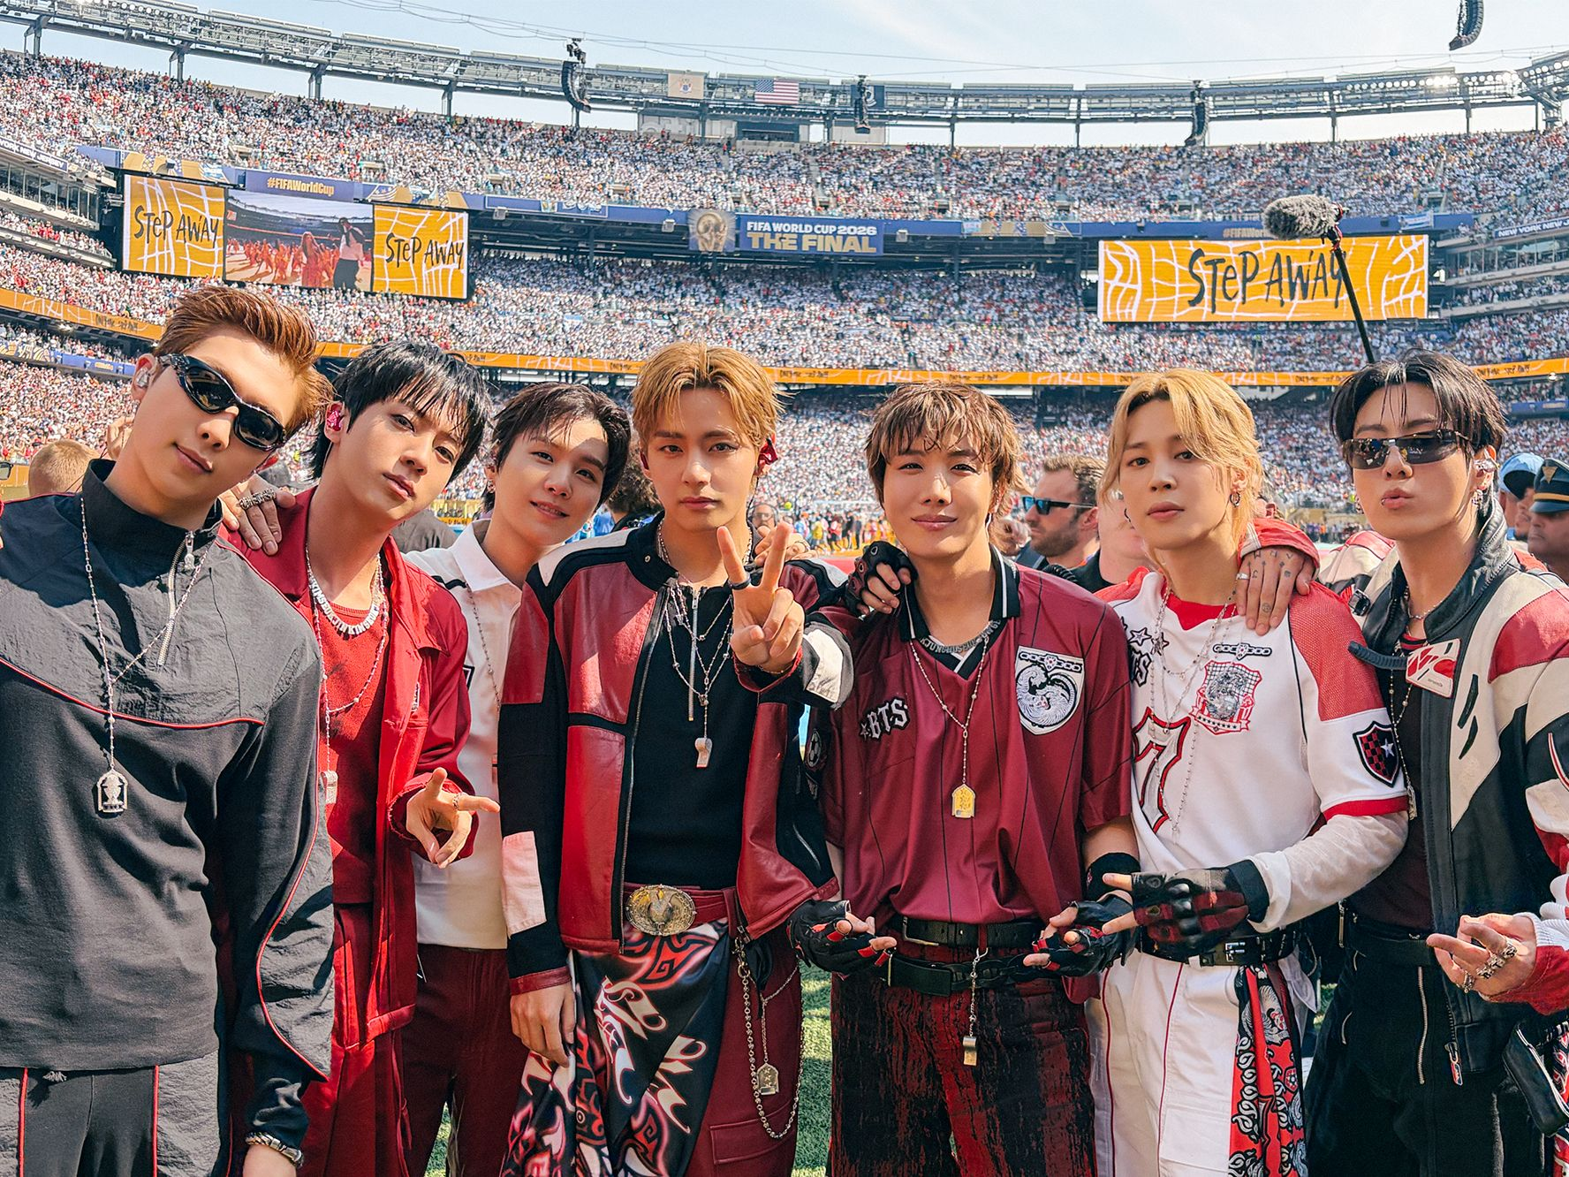
Taking over the FIFA World Cup 2026 stage with unmatched grace and explosive energy! ⚽🔥
Even without a sea of purple, BTS completely owned the stadium, turning the world's biggest sports stage into their own concert. Pure power, flawless performance, and total dominance—the kings are back and they shook the globe! ✨🎤
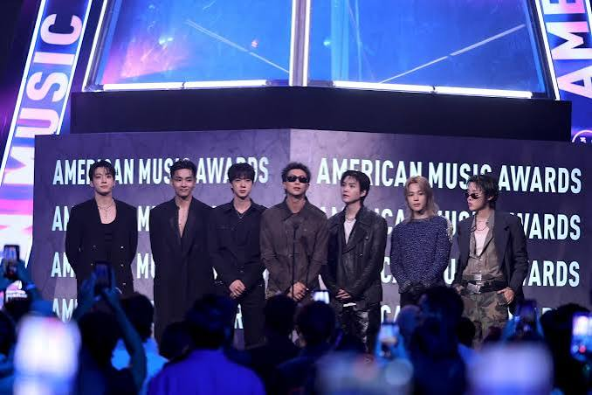
AMA award 2026 back to back won in3 categories with a massive difference

MANY MORE IS LOADING cause
“HATERS GONNA HATE PLAYERS GONNA PLAY, we don’t say HELLO we say ANNYEONGHASEYO”- RM
You can’t stop us loving ourselves-IDOL

